Lesson Plan Title: Movements Length: Two Classes

Note: Before you plan and write art experiences; pre-assess your students based on the proposed concepts, enduring understandings, and objectives of the unit/lesson(s). You may also gather this information from (previous) teachers, by reviewing already completed art work, consulting curriculum materials, etc., to get a better understanding of what content students already know and what they will need to know to be successful.

Pre-Assessment:
This will need to be done prior to teaching your lesson. Outline the method you will use to determine the skill/knowledge level of your students based on the concepts/enduring understandings/objectives of the lesson. (Hint: turn these into questions.) Be specific in describing what you would recognize as proficient skill/knowledge.
Did students use their sketchbooks and explore their own body movements, and create a sculpture of a figure or an object in motion.
Given examples of contemporary sculptures and a teacher’s example, did students identify and utilize techniques and styles that capture movement into their own three-dimensional art work.
Did students use completed art works, to explain their decision making process and a story behind their sculpture.
By using the discovery board, students were able to communicate and express what they learned to the rest of the class

Performance:
What will students accomplish as a result of this lesson? This can be presented to students in the form of a story. In this narrative the students take on a role and create a learning product about a specific topic for a certain audience. (RAFT – Role / Audience / Format / Topic)
You are going to be sculptors today! And our creation is going to focus on movement!

As a sculptor, there are many options you can choose to build artwork with. Today, we are going to use pipe cleaners to make a sculpture of a person or figure who is moving.

Concepts:
List the big ideas students will be introduced to in the lesson. These ideas are universal, timeless and transferrable. Examples of concepts used in art might include: Composition, Patterns, Technique, Rhythm, Paradox, Influence, Style, Force, Culture, Space/Time/Energy, Line, Law/Rules, Value, Expressions, Emotions, Tradition, Symbol, Movement, Shape, Improvisation, and Observation Look for concepts in the standards, content specific curriculum, etc.
Three-dimensional, movement, shape, planning .

Enduring Understanding (s):
Enduring Understandings show a relationship between two or more concepts; connected with an active verb. The best enduring understandings not only link two or more concepts; but demonstrate why this relationship is important. Like concepts, they are timeless, transferrable and universal. Align Standards, Prepared Graduate Competencies (PGCs) and Grade Level Expectations (GLEs) to Enduring Understandings.
Art work planned in a two-dimensional format can be transformed into a three-dimensional art work that captures movement.
By exploring our body movements and positions, students will assemble a three-dimensional art work that captures a figure or object in motion.

Standards: (All lessons should address all standards.)
1. Observe and Learn to Comprehend
2. Envision and Critique to Reflect
3. Invent and Discover to Create
4. Relate and Connect to Transfer

Objectives/Outcomes/Learning Targets:
Objectives describe a learning experience with a condition → behavior (measurable) → criterion. Aligned to: Bloom’s – Standards – GLEs - Art learning and, when appropriate, Numeracy, Literacy and Technology. Should be written as: Objective. (Bloom’s: _____ - Standard: _____ - GLE: _____ -Art learning: _____ -Numeracy, Literacy, and/or Technology)
- Using gesture drawings, TSWBAT create a sculpture of a figure or an object in motion. (Bloom’s: Creating - Standard: # 3 - GLE: # 3.1 -Art learning: Create -Numeracy, Literacy)
- Given pipe cleaners, TSWBAT build a figurative sculpture in action. (Bloom’s: Creating - Standard: # 3 - GLE: # 3.1 -Art learning: Create -Numeracy, Literacy)
- Given examples of Mason and Giacometti, TSWBAT identify how movement was captured. (Bloom’s: Analyzing - Standard: # 2 - GLE: # 2.1 -Art learning: Identify -Numeracy, Literacy)
- By using the discovery board, TSWBAT communicate and express how they portrayed movement in their sculptures and drawings. (Bloom’s: Remembering - Standard: # 4 - GLE: # 4.1 -Art learning: Communicate -Numeracy, Literacy)
- Using pipe cleaner sculptures, TSWBAT describe how they portrayed movement during the building process. (Bloom’s:analyze- Standard 2.1- GLE- 2.1 - Art Learning: identify)

Differentiation:
Explain specifically how you have addressed the needs of exceptional students at both end of the skill and cognitive scale. Describe the strategies you will use for students who are already proficient and need growth beyond what you have planned for the rest of the class, as well as modifications for students with physical and/or cognitive challenges. Students must still meet the objectives.

Differentiation:  (Multiple means for students to access content and multiple modes for student to express understanding.) | Access (Resources and/or Process) | Expression (Products and/or Performance)
 | - Drawing, planning verbally, exploring motion kinesthetically, and working three dimensionally  - Work and share ideas in small groups | - Planning process happens in a wide variety of ways
Extensions for depth and complexity: | Access (Resources and/or Process) | Expression (Products and/or Performance)
 | 1.Students can create a story based on their sculpture and verbally communicate at the end of class.  2.Students can create and write a title for the art work. | - Students can reflect on their ideas and artistic decisions to create a story, therefore engaging in literacy practice and improvise creative ideas.  - Students can practice writing skills and internalize their decisions to create the title.

Literacy:
List terms (vocabulary) specific to the topic that students will be introduced to in the lesson and describe how literacy is integrated into the lesson.
Vocabulary: two-dimensional, three-dimensional, discovery, movement, planning.

Literacy Integration: Verbalization of planning, verbalization of thoughts on sculpture

Materials:
Must be grade level appropriate. List everything you will need for this lesson, including art supplies and tools. (These are the materials students will use.) List all materials in a bulleted format.
Pipe cleaners, acrylic paint, paint brushes, large pieces of paper, learning target board, discovery board, card board to use as a stand for finished sculptures,

Resources:

List all visual aids and reference material (books, slides, posters, etc. Be specific; include title, artist, etc. Make reference to where the material can be found. (These are the resources used by the teacher to support/develop the lesson.) List all resources in a bulleted format.
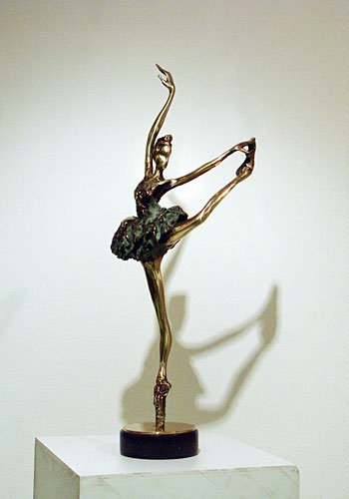
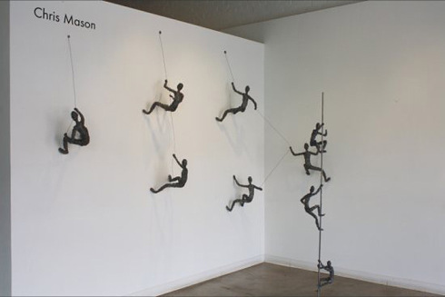 Ivan Minekov
Social Climbing, Chris Mason https://fineartebooks.wordpress.com/tag/modern-sculpture/
http://collabcubed.com/2012/05/08/chris-mason-social-climbing/
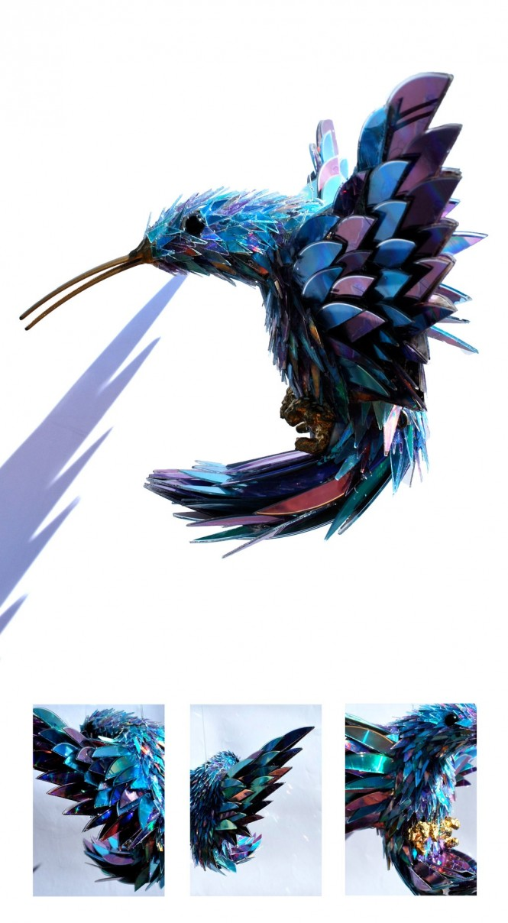
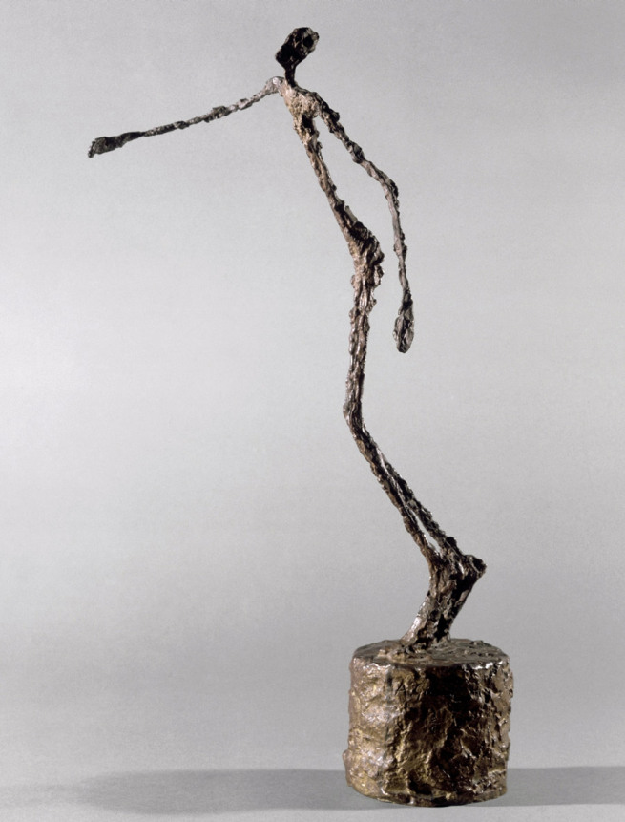
Sean E. Avery,http://www.home-designing.com/2012/02/stunning-sculptures-made-from-discarded-cd-fragments Alberto Giacometti
Homme qui chavire/Falling Man
1950
Bronze, 60 x 22 x 36 cm
http://artblart.com/tag/alberto-giacometti-figurine-dans-une-boite-entre-deux-boites-qui-sont-des-maisons/

Preparation:
What do you need to prepare for this experience? List steps of preparation in a bulleted format.
- create own sculpture in motion
- create a discovery board
- create a learning target board

Safety:

Be specific about the safety procedures that need to be addressed with students. List all safety issue in a bulleted format.
- Be careful with pipe cleaners. We do not use them to hit other students with, we should only be using them to build our sculptures
- When demonstration is being given on how to connect pipe cleaners together, be sure to not be touching anything.
- During gesture painting activity and freeze game, we need to be aware of our surrounds so we do not hit our classmates.

Action to motivate/Inquiry Questions:
Describe how you will begin the lesson to stimulate student’s interest. How will you pique their curiosity and make them interested and excited about the lesson? What inquiry questions will you pose? Be specific about what you will say and do to motivate students and get them thinking and ready to participate. Be aware of the varying range of learning styles/intelligences of your students. Some ideas might include: telling a story, posing a series of questions, role-playing, etc.
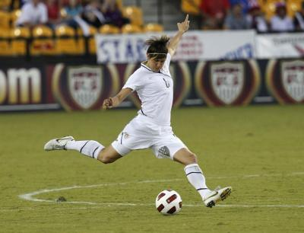
“If you were playing soccer what would it look when you kicked the ball?”
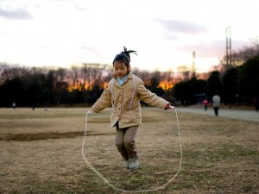
http://www.livestrong.com/article/245450-techniques-to-kick-a-soccer-ball-far/
http://transformfxfitness.com/2014/02/10-reasons-you-should-be-jumping-rope/

Ideation/Inquiry:
Ideation is the creative process of generating, developing, and communicating new ideas, where an idea is understood as a basic element of thought that can be visual, concrete or abstract. List and describe inquiry questions and processes you will engage students in to help them develop ideas and plans for their artwork.
- “Freeze” game to help students see and feel what movement looks like
- Gesture painting activity

Instruction:
Give a detailed account (in bulleted form) of what you will teach. Be sure to include approximate time for each activity and instructional methodology: skills, lecture, inquiry, etc. Include motivation and ideation/inquiry where appropriate; including what student will understand as a result of the art experience

Day 1 | Instruction - The teacher will... (Be specific about what concepts, information, understandings, etc. will be taught.) Identify instructional methodology. KNOW (Content) and DO (Skill)  - Start off class at the purple rug. Introduce the discovery board: What are some things you learned last week? If they cannot think of anything, remind some of them (some tried overlapping colors, some tried overlapping oil pastels and paint). Pull out the discovery board and explain that at the end of each class, we will post new things that the students learned and let them share with the class.  - Introduce the next lesson: Movement Monuments. You are going to try and capture your friends in motion and show what that looks like in both drawings and sculptures.  - What does it mean to be in motion? What would it look like to be in motion? How can art, which does not move, show something that is in motion?  - After students are done explaining what they know, teachers will explain motion is the “act of changing location or position”, which happens when we are moving around and doing things.  - Show images to students of contemporary artists who portrayed movement and motion in their art work. Ask students what do they see, how do they know the object is moving, etc.  - After looking at some images, we will go outside to start our activities.Our first activity is a little game we will call FREEZE! When we yell “freeze” all the students must stop right where they are. The teachers will ask students, “What does it look like to...play soccer? Dance? Play with friends?” After the group has done several examples, explain that we are going to make our sculptures look like we are moving and to think about what it looked like when their classmates were frozen.  - The next activity will be outside too. Teachers will put students in groups of two and students will each go to a drawing station. Students will pick one person to be a model and one person to draw, both will get a chance to do each job, so it does not matter who goes first. The teachers will demonstrate what it looks like for one person to model and one person to draw. Emphasize that we are trying to draw the model in motion. Teachers will give different prompts for models to act out so they aren’t lost. After each student gets practice or get bored, we will go inside to build the sculpture.  - Demonstrate different techniques of how to build with the pipe cleaners. Show students how they can connect two pieces together by folding, propping up the figure, etc.  - Students can begin to work on their sculptures. The figure in motion can be doing whatever the students want it to be doing. Teachers will be helping students balance their pieces while documenting.  - When class is about over, will collect all of the sculptures by table into boxes. Each table is responsible for cleaning their pipe cleaners and supplies into their bins.  - Once students have cleaned, we will sit in the front of the classroom and fill our the discovery board. What did you learn about motion? What did you learn about gesture drawing? What did you learn about sculpting with pipe cleaners? | Learning - Students will... i.e.: explore ideation by making connections,  comparing, contrasting; synthesize possibilities for each painting technique; etc. (Be specific about what will be the intended result of the instruction as it relates to learning.) UNDERSTAND  - Comparing analogous situations: transferring insights to new contexts  - Clarifying and analyzing the meanings of words or phrases  - Analyzing or evaluating action  - Refining generalizations and avoiding oversimplification; making plausible inferences, predictions, or interpretations  - comparing and contrasting ideals with actual practice  - Exercising fair-mindedness and developing intellectual good faith or integrity  - exercising fair-mindedness  - Reasoning dialogically: comparing perspectives, interpretations; practicing Socratic discussion: clarifying and questioning | Time
Day 2 | - Depending if class gets done building on their project or not, today is a work day to finish up. If not everyone is done building their projects, will have another activity planned in connection to movement. If everyone did finish, will paint the fired sculptures. But, will write day in-depth lesson plan after we see where the students were at. | - Developing intellectual perseverance
Day 3

Student reflective/inquiry activity:
Sample questions and activities (i.e. games, gallery walk, artist statement, interview) intended to promote deeper thinking, reflection and refined understandings precisely related to the grade level expectations. How will students reflect on their learning? A participatory activity that includes students in finding meaning, inquiring about materials and techniques and reflecting about their experience as it relates to objectives, standards and grade level expectations of the lesson.)
Discovery board discussion about what the students learned in class.

Post-Assessment (teacher-centered/objectives as questions):  Have students achieved the objectives and grade level expectations specified in your lesson plan? | Post-Assessment Instrument:  How well have students achieved the objectives and grade level expectations specified in your lesson plan? Include your rubric, checklist, rating scale, etc.
- Did students use their sketchbooks and explore their own body movements, and create a sculpture of a figure or an object in motion.  - Given pipe cleaner,did students build a three-dimensional work using additive and subtractive art techniques.  - Given examples of contemporary sculptures and a teacher’s example, did students identify and utilize techniques and styles that capture movement into their own three-dimensional art work.  - Did students use completed art works, to explain their decision making process and a story behind their sculpture.  - By using the discovery board, students were able to communicate and express what they learned to the rest of the class | Student_______________________  1. Used sketchbook to explore body movements of a figure in motion. ________  2. Used pipe cleaners to build a three-dimensional work using additive art techniques. ________  3. Identified and utilized techniques and styles that capture movement. ________  4. Used completed art works to explain decision making process. ________  5. Communicated and expressed what was learned during class. ________  Super Duper: Work is finished, unique, and has a lot of detail.  Good Work: Work is finished, unique, and has detail.  Okay: Work is finished with little detail.  Almost There! : Work is not finished.

Self-Reflection:
After the lesson is concluded write a brief reflection of what went well, what surprised you, and what you would do differently. Specifically address: (1) To what extent were lesson objectives achieved? (Utilize assessment data to justify your level of achievement.) (2) What changes, omissions, or additions to the lesson would you make if you were to teach again? (3)What do you envision for the next lesson? (Continued practice, reteach content, etc.)
Nicole:

What worked well for this art experience? Why?
We had the students do gesture paintings and I believe that it went pretty well. They all seemed to be very excited about doing the activity. They all worked very hard and were able to paint their partners in many different poses.
What didn’t work well for this art experience? Why?
We were planning on doing the gesture paintings outside on large pieces of paper, but once we arrived at school to set up it was much too windy. WE tried to set our large pieces of paper but the wind was a much bigger issue than we thought. We were not as prepared for the wind as we should have, and we didn’t have a concrete back up plan so we had to think on our feet to make the class run as smooth as possible. What would you do differently? Why?
I would definitely, in the future, have a very concrete backup plan in place. I would also maybe spread out this activity across an entire week and go more in depth about what was expected and ways to use the materials. I think overall working with kindergartners, as of right now I feel that it is better to give multiple small projects that can build into one rather than a bunch of big projects that follow a theme.

Jenna:
What worked well for this art experience? Why?
Students came up with interesting ideas were creating really interesting sculptures with their pipe cleaners.

What didn’t work well for this art experience? Why?
There was a lot that did not go smoothly with this class. The first thing was that we did not really prepare for if the weather was bad for our first big activity. We were unable to do the entire activity and had to use our sketchbooks inside. Another thing was that we were too ambitious with our lesson plan for this age group. Things would have worked much better if we kept them simple. The students understood for the most part what we were saying, but with how many actives we had planned and the concept, it was a little too much for kindergarteners. Finally, because the class was a little hectic, there were some behavioral issues. There were a couple students who did not want to participate. This might have been because the instruction was not running smooth and not as clear as it could have been.

What would you do differently? Why?
Next time, we need to be more thoughtful in our planning and make sure that we have solid backup plans. We threw around some ideas on what we would do if certain things were to happen, but never actually made a plan incase something didn’t work out. Next, as we continue to work with the students, we continue to understand their developmental ability a bit more. We are still not making things simple enough always need to keep in mind that this is their first year in school, so they need the foundations of art and nothing complicated. Finally, making sure that the instructions are clear and to the point will help with management. These young students need to know exactly what we expect as teachers and how they can get there. Although it was a stressful class, I learned a lot from the experience and got a lot of great feedback.

Appendix: Include all handouts, prompts, written materials, rubrics, etc. that will be given to students.

8/9/15 Fahey

