Lesson Plan Title: Artist Trading Cards Length:One Day

Note: Before you plan and write art experiences; pre-assess your students based on the proposed concepts, enduring understandings, and objectives of the unit/lesson(s). You may also gather this information from (previous) teachers, by reviewing already completed art work, consulting curriculum materials, etc., to get a better understanding of what content students already know and what they will need to know to be successful.

Pre-Assessment:
This will need to be done prior to teaching your lesson. Outline the method you will use to determine the skill/knowledge level of your students based on the concepts/enduring understandings/objectives of the lesson. (Hint: turn these into questions.) Be specific in describing what you would recognize as proficient skill/knowledge.
What do artists make art about?
What does it mean to ‘express yourself’?
What are some things you like about yourself? Are you smart? Adventurous? Silly? How could you express that in art?

Performance:
What will students accomplish as a result of this lesson? This can be presented to students in the form of a story. In this narrative the students take on a role and create a learning product about a specific topic for a certain audience. (RAFT – Role / Audience / Format / Topic)
You are a new artist in Fort Collins and you want to get your name out into the community! You think that making a personal trading card would be a GREAT way to get your info out into the community. You want your trading card to have an image or images that reflect what you like.

Concepts:
List the big ideas students will be introduced to in the lesson. These ideas are universal, timeless and transferrable. Examples of concepts used in art might include: Composition, Patterns, Technique, Rhythm, Paradox, Influence, Style, Force, Culture, Space/Time/Energy, Line, Law/Rules, Value, Expressions, Emotions, Tradition, Symbol, Movement, Shape, Improvisation, and Observation Look for concepts in the standards, content specific curriculum, etc.
Artist intention, expression.

Enduring Understanding (s):
Enduring Understandings show a relationship between two or more concepts; connected with an active verb. The best enduring understandings not only link two or more concepts; but demonstrate why this relationship is important. Like concepts, they are timeless, transferrable and universal. Align Standards, Prepared Graduate Competencies (PGCs) and Grade Level Expectations (GLEs) to Enduring Understandings.
- Self-expression can be achieved by planning and manipulating materials to represent a personal interest of the artist.
- Artists represents themselves in many multiple forms of mediums.

Standards: (All lessons should address all standards.)
1. Observe and Learn to Comprehend
2. Envision and Critique to Reflect
3. Invent and Discover to Create
4. Relate and Connect to Transfer

Objectives/Outcomes/Learning Targets:
Objectives describe a learning experience with a condition → behavior (measurable) → criterion. Aligned to: Bloom’s – Standards – GLEs - Art learning and, when appropriate, Numeracy, Literacy and Technology. Should be written as: Objective. (Bloom’s: _____ - Standard: _____ - GLE: _____ -Art learning: _____ -Numeracy, Literacy, and/or Technology)
- Provided examples of game and artist trading cards, TSWBAT utilize collage or found objects in at least one sketch or their artist trading card that effectively express themselves. (Bloom’s: Applying - Standard: #2 - GLE: #2.1 - Art learning: Develop Craft - Numeracy, Literacy, and Technology)
- Given sketchbooks, TSWBAT produce four detailed sketches of different ideas or themes for their artist trading cards that show their interests or personality. (Bloom’s: Applying - Standard: # 3 - GLE: # 3.1 - Art learning: Ideation - Numeracy, Literacy)
- Given two-dimensional and small three-dimensional materials, TSWBAT create at least one trading card that represents them. (Bloom’s: Creating - Standard: # 3 - GLE: # 3.1 - Art learning: Create - Numeracy, Literacy)
- Through creating artist trading cards, TSWBAT express themselves using figural representation of themselves or an important person in their lives, personal interests, or anything that they think describes them. (Bloom’s: Applying - Standard:# 1 - GLE: # 1.2 - Art learning: Understand Art World - Numeracy, Literacy)
- Using the finished trading cards, TSWBAT verbally describe their ATC and explain to the class how the cards represent themselves. (Bloom’s: Understanding - Standard: # 2 - GLE: # 2.1 - Art learning: Reflect - Literacy)

Differentiation:
Explain specifically how you have addressed the needs of exceptional students at both end of the skill and cognitive scale. Describe the strategies you will use for students who are already proficient and need growth beyond what you have planned for the rest of the class, as well as modifications for students with physical and/or cognitive challenges. Students must still meet the objectives.

Differentiation:  (Multiple means for students to access content and multiple modes for student to express understanding.) | Access (Resources and/or Process) | Expression (Products and/or Performance)
 | Students have the option to create postcards, folding cards, or other small representations of self-expression.  Students have the option to also work with small three-dimensional objects on top of the two-dimensions. | Students are not limited to trading cards. They can decide the format of their artist card.
Extensions for depth and complexity: | Access (Resources and/or Process) | Expression (Products and/or Performance)
 | Students can create a pack of cards that go together under a common theme.  Students can create packaging they think would go well with their cards. | Students can come up with a description about themselves to put on the card

Literacy:
List terms (vocabulary) specific to the topic that students will be introduced to in the lesson and describe how literacy is integrated into the lesson.
Vocabulary: Artist trading cards, design, self-expression.

Literacy integration: oral story telling, writing on the cards.

Materials:
Must be grade level appropriate. List everything you will need for this lesson, including art supplies and tools. (These are the materials students will use.) List all materials in a bulleted format.
Cardstock
Scrapbook paper
3-D objects
Coloring utensils-markers, oil pastels, colored pencils
Glue
Examples
Acrylic Paint
Brushes
Plates
Cups
Paper punch cutter

Resources:

List all visual aids and reference material (books, slides, posters, etc. Be specific; include title, artist, etc. Make reference to where the material can be found. (These are the resources used by the teacher to support/develop the lesson.) List all resources in a bulleted format.
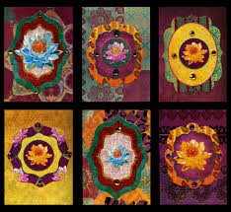Christine Adolph
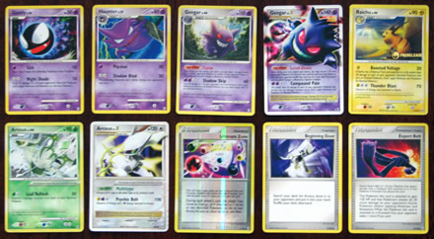Pokemon cards
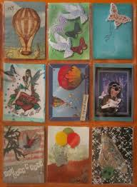 Various Artists from Sweden

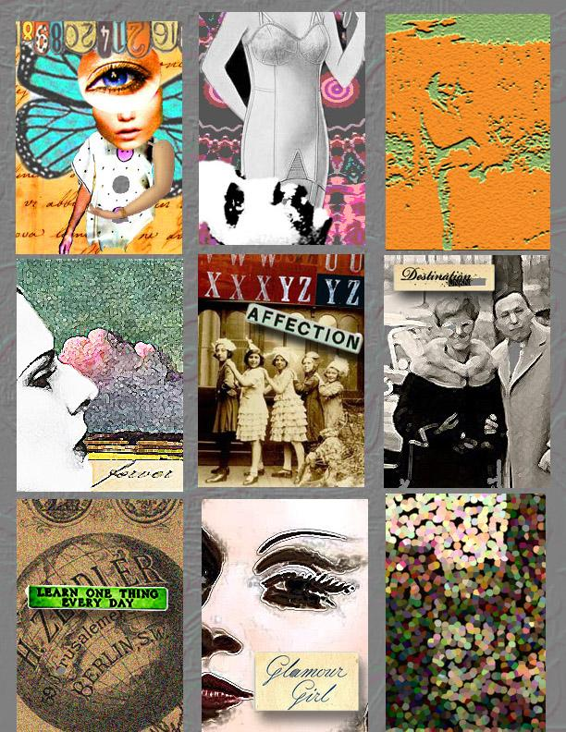 Briedah Designs

Preparation:
What do you need to prepare for this experience? List steps of preparation in a bulleted format.
Cut down the card stock into the size of the trading cards.
Organize a container of small found objects.
Prepare a slide show with examples.

Safety:

Be specific about the safety procedures that need to be addressed with students. List all safety issue in a bulleted format.
Be careful with the hot glue gun, use glove.

Action to motivate/Inquiry Questions:
Describe how you will begin the lesson to stimulate student’s interest. How will you pique their curiosity and make them interested and excited about the lesson? What inquiry questions will you pose? Be specific about what you will say and do to motivate students and get them thinking and ready to participate. Be aware of the varying range of learning styles/intelligences of your students. Some ideas might include: telling a story, posing a series of questions, role-playing, etc.
Come to class wearing wacky outfits. Jenna will wear her turkey hat and a mustache. Nicole will wear an artist beret.
Students will be asked what they notice about our outfits and how our outfits might tell people who we are as a person.

Ideation/Inquiry:
Ideation is the creative process of generating, developing, and communicating new ideas, where an idea is understood as a basic element of thought that can be visual, concrete or abstract. List and describe inquiry questions and processes you will engage students in to help them develop ideas and plans for their artwork.
- Classroom discussion of what trading cards are and what they represent.
- Four sketches of what ideas for their artist trading cards.
- While students are working, verbally express their thought process.

Instruction:
Give a detailed account (in bulleted form) of what you will teach. Be sure to include approximate time for each activity and instructional methodology: skills, lecture, inquiry, etc. Include motivation and ideation/inquiry where appropriate; including what student will understand as a result of the art experience

Day 1 | Instruction - The teacher will... (Be specific about what concepts, information, understandings, etc. will be taught.) Identify instructional methodology. KNOW (Content) and DO (Skill)  - When adults with careers are meeting new people and making connections, they can introduce themselves by giving them business cards. Business cards are a way to introduce who a person is and what they do. As artists, we make things unique and creative. So let’s make our own versions of a business card...an artist trading card!  - Slide show of trading cards. Really emphasize that not all trading cards have to look like Pokemon cards or sports cards, but have no limitations on what you choose to incorporate. What are some features you notice? Figures? Words? Colors?  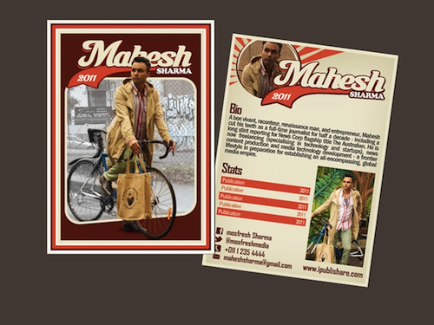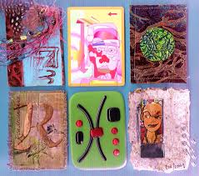  - Before handing out materials, students will sketch for ideas of their ATCs. Teachers will circulate while students are sketching to make sure students have a reasoning for their themes and decisions.  - After about four sketches are done, bins with materials will be distributed in on their tables. The materials will be very intentional, with only drawing materials and smaller found objects. There will be a station for students to get a palette of distributed acrylic paint if they would like as well as a bin for 3-D materials like fabric, roving, etc.  - Students will create their ATCs. They can create multiple or spend more time on just one. They will be provided two different pieces of card stock for the front and the back so that student are not waiting on one side to dry. If they finish early, have the option to make a set of cards with one theme, create packaging for their cards, or draw a story behind their sketchbook.  - Clean up: every student must put drawing materials and found objects in their bins. Floor and table must be clean if they want to go to recess. Each table will be approved before joining the class on the purple carpet.  - Class discussion about the project. What did you like? What did you learn? If you could do it again, what would you put on your artist trading card? How would you use your trading cards if you had a pack of them?  - Show students the teachers’ examples of their trading cards. What do they see? What does it mean? How do they know? | Learning - Students will... i.e.: explore ideation by making connections,  comparing, contrasting; synthesize possibilities for each painting technique; etc. (Be specific about what will be the intended result of the instruction as it relates to learning.) UNDERSTAND  - Making Plausible inferences; giving reasons and evaluating evidence  - Noting significant similarities and differences; examining or evaluating assumptions.  - refining generalizations and avoiding oversimplifications; comparing analogous situations: transferring insights to new contexts  - Generating and assessing solutions  - Comparing and contrasting ideals with actual practice; thinking precisely about thinking  - Exercising fair-mindedness  - Analyzing or evaluating actions | Time  8:15  8:20  8:30  8:45  9:15  9:20  9:25

Student reflective/inquiry activity:
Sample questions and activities (i.e. games, gallery walk, artist statement, interview) intended to promote deeper thinking, reflection and refined understandings precisely related to the grade level expectations. How will students reflect on their learning? A participatory activity that includes students in finding meaning, inquiring about materials and techniques and reflecting about their experience as it relates to objectives, standards and grade level expectations of the lesson.)
Students will each describe their trading card, and then students will all be given a pack of the classroom trading cards

Post-Assessment (teacher-centered/objectives as questions):  Have students achieved the objectives and grade level expectations specified in your lesson plan? | Post-Assessment Instrument:  How well have students achieved the objectives and grade level expectations specified in your lesson plan? Include your rubric, checklist, rating scale, etc.
- Provided examples of game and artist trading cards, did the student utilize stylistic qualities in at least one sketch or the final trading card?  - Given sketchbooks, did the student produce four detailed sketches of different ideas or themes for their artist trading cards?  - Given two-dimensional and small three-dimensional materials, did the student create at least one trading card that represents them?  - Through creating artist trading cards, did the student express themselves using figural representation of themselves or an important person in their lives, personal interests, or anything that they think describes them?  - Using the finished trading cards, did the student verbally describe their ATC and explain to the class how the cards represent themselves? | Student_______________________  1. Utilized stylistic qualities in at least one sketch or the final trading card seen in examples.________  2. Created four detailed sketches of different ideas and themes for trading card.________  3. Created at least one trading card that represents them using two and three dimensional materials. ________  4. Created a trading card that represented themselves either figuratively or through personal interests.________  5. Verbally describe their ATC and explain to the class how the cards represent themselves. _________  Super Duper: Work is finished, unique, and has a lot of detail.  Good Work: Work is finished, unique, and has detail.  Okay: Work is finished with little detail.  Almost There! : Work is not finished.

Self-Reflection:
After the lesson is concluded write a brief reflection of what went well, what surprised you, and what you would do differently. Specifically address: (1) To what extent were lesson objectives achieved? (Utilize assessment data to justify your level of achievement.) (2) What changes, omissions, or additions to the lesson would you make if you were to teach again? (3)What do you envision for the next lesson? (Continued practice, reteach content, etc.)
Jenna
What worked well for this art experience? Why?

For this class, we struggled with a quicker activity that would excited the students. The project was to create artist trading cards that were personal. The students were really excited about the project because of their interests in things like Pokemon cards and the found-object materials. There were not really any students who did not work hard on their projects, as all of them were excited to do it and got sad when it was time to clean up.

What didn’t work well for this art experience? Why?

There were a lot of behavior issues this class that I was unsure how to fix. Usually it is just one or two students that are distracted and not focused, but there were seven or eight students this class that needed to be pulled aside because they were having issues. A couple of them could not really keep their hands to themselves or were making hurtful comments to their peers. I was unsure how to handle this, and pulled the groups or individuals aside and asked what was going on which did not really seem to do anything.

What would you do differently? Why?

Next time, I would not spend so much time talking to the students but simply separate them or send them next to Julie’s desk to calm down and come back when they are ready. Talking with them did not get anything accomplished and only took time out of class. If this happens next class, I will simply separate the students and if they keep having issues just send them to sit by themselves. It is hard to act like that with the students, but they do not seem to take it personally and expect to get in trouble from the adult, so I need to not hesitate and quickly solve the issue.

Nicole:
What worked well for this art experience? Why?
This lesson we had the kids make Artist Trading Cards as a way to use art to tell viewers about themselves. All of the students were excited to make their own trading card. Many of the boys made cards that were very similar to Pokémon cards. One student, Wrenna, put a wren on her trading card because wren is in her name.
What didn’t work well for this art experience? Why?
The boys started to argue with each other about types of Pokémon. A couple students wanted to make up Pokémon and other students would get upset with them. We also gave students two different pieces of card stock, one for the front and one for the back. We told students that we would glue the pieces together for them later, but some students didn’t understand and glued their own papers together.
What would you do differently? Why?
I think that we could have communicated the gluing aspect of the lesson to the students better. It wasn’t a big issue that they glued their own pieces together but I think it shows that they missed something we said so we need to make sure that they completely understand what their instructions are before we start the project.

Appendix: Include all handouts, prompts, written materials, rubrics, etc. that will be given to students.

8/9/15 Fahey

