Lesson Plan Title: Transportation Length: Two Days

Note: Before you plan and write art experiences; pre-assess your students based on the proposed concepts, enduring understandings, and objectives of the unit/lesson(s). You may also gather this information from (previous) teachers, by reviewing already completed art work, consulting curriculum materials, etc., to get a better understanding of what content students already know and what they will need to know to be successful.

Pre-Assessment:
This will need to be done prior to teaching your lesson. Outline the method you will use to determine the skill/knowledge level of your students based on the concepts/enduring understandings/objectives of the lesson. (Hint: turn these into questions.) Be specific in describing what you would recognize as proficient skill/knowledge.
- Define motion
- Define visual characteristics of a figure in motion
- Define the differences between two-dimensional and three-dimensional

Performance:
What will students accomplish as a result of this lesson? This can be presented to students in the form of a story. In this narrative the students take on a role and create a learning product about a specific topic for a certain audience. (RAFT – Role / Audience / Format / Topic)
20 years into the future, you are one of the top builders in the world! You are asked to build a new form of transportation. You have to come up with a new idea, this means that you can combine features of transportation that are already invented or completely invent a new one! We will use found objects to show your new invention. The future of moving across the town depends on you!

Concepts:
List the big ideas students will be introduced to in the lesson. These ideas are universal, timeless and transferrable. Examples of concepts used in art might include: Composition, Patterns, Technique, Rhythm, Paradox, Influence, Style, Force, Culture, Space/Time/Energy, Line, Law/Rules, Value, Expressions, Emotions, Tradition, Symbol, Movement, Shape, Improvisation, and Observation Look for concepts in the standards, content specific curriculum, etc.
- Movement
- Motion
- Transportation
- Form
- Technique

Enduring Understanding (s):
Enduring Understandings show a relationship between two or more concepts; connected with an active verb. The best enduring understandings not only link two or more concepts; but demonstrate why this relationship is important. Like concepts, they are timeless, transferrable and universal. Align Standards, Prepared Graduate Competencies (PGCs) and Grade Level Expectations (GLEs) to Enduring Understandings.
Materials and stylistic decisions display artist intention that portray movement and creative modes for transportation.

Understanding of motion and historical background will ignite creative thinking and story telling.

Standards: (All lessons should address all standards.)
1. Observe and Learn to Comprehend
2. Envision and Critique to Reflect
3. Invent and Discover to Create
4. Relate and Connect to Transfer

Objectives/Outcomes/Learning Targets:
Objectives describe a learning experience with a condition → behavior (measurable) → criterion. Aligned to: Bloom’s – Standards – GLEs - Art learning and, when appropriate, Numeracy, Literacy and Technology. Should be written as: Objective. (Bloom’s: _____ - Standard: _____ - GLE: _____ -Art learning: _____ -Numeracy, Literacy, and/or Technology)
- Using sketches, TSWBAT devise characteristics they will incorporate into their three-dimensional structure. (Bloom’s:Creating - Standard: # 3 - GLE: # 3.1 - Art learning: Ideation - Numeracy, Literacy, and Technology)
- Provided a slide show on transportation, TSWBAT to identify how technology has influenced the ways humans travel around the world. (Bloom’s: Analyzing - Standard: # 2 - GLE: # 2.1 - Art learning: Identify - Numeracy, Literacy, and Technology)
- Given found objects, TSWBAT create a transportation object that incorporates realistic characteristics or fictional creations using additive techniques. (Bloom’s: Creating - Standard: # 3 - GLE: # 3.1 - Art learning: Create - Numeracy, Literacy, and Technology)
- Using completed art work, TSWBAT summarize a story of how their invention will work. (Bloom’s: Understanding - Standard:# 2 - GLE: # 2.1 - Art learning: Story telling - Numeracy, Literacy, and Technology)
- Using completed sculpture and the hearing the stories behind it, TSWBAT explain how their object is relation to motion. (Bloom’s: Understanding - Standard: # 4 - GLE: # 4.1 - Art learning: Intent/Connections​ - Literacy)

Differentiation:
Explain specifically how you have addressed the needs of exceptional students at both end of the skill and cognitive scale. Describe the strategies you will use for students who are already proficient and need growth beyond what you have planned for the rest of the class, as well as modifications for students with physical and/or cognitive challenges. Students must still meet the objectives.

Differentiation:  (Multiple means for students to access content and multiple modes for student to express understanding.) | Access (Resources and/or Process) | Expression (Products and/or Performance)
 | - Slide show to see examples, verbally talk about the ways we get around, work in both 2-D and 3-D. | - Provide information to reach a variety of learning styles
Extensions for depth and complexity: | Access (Resources and/or Process) | Expression (Products and/or Performance)
 | - Students can create a background and surface on paper and cardboard if they finish early.  - have students create a name for their types of transportation | - Students can think about the environment that would surround their sculpture  - students can transfer visual understanding into a verbal one.

Literacy:
List terms (vocabulary) specific to the topic that students will be introduced to in the lesson and describe how literacy is integrated into the lesson.
Vocabulary: three-dimensional, found objects, additive techniques.

Literacy integration: present oral story about how to use your new invention

Materials:
Must be grade level appropriate. List everything you will need for this lesson, including art supplies and tools. (These are the materials students will use.) List all materials in a bulleted format.
Found objects, hot glue

Resources:

List all visual aids and reference material (books, slides, posters, etc. Be specific; include title, artist, etc. Make reference to where the material can be found. (These are the resources used by the teacher to support/develop the lesson.) List all resources in a bulleted format.
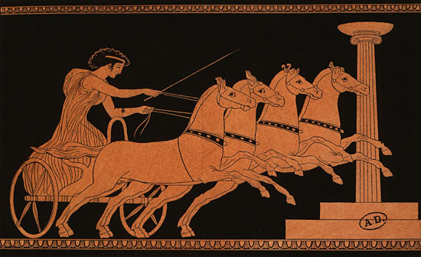
ancientpeoples.tumblr.com

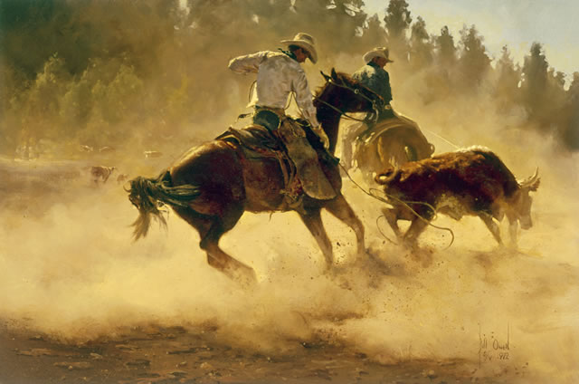
Bill Owen
www.billowenca.com

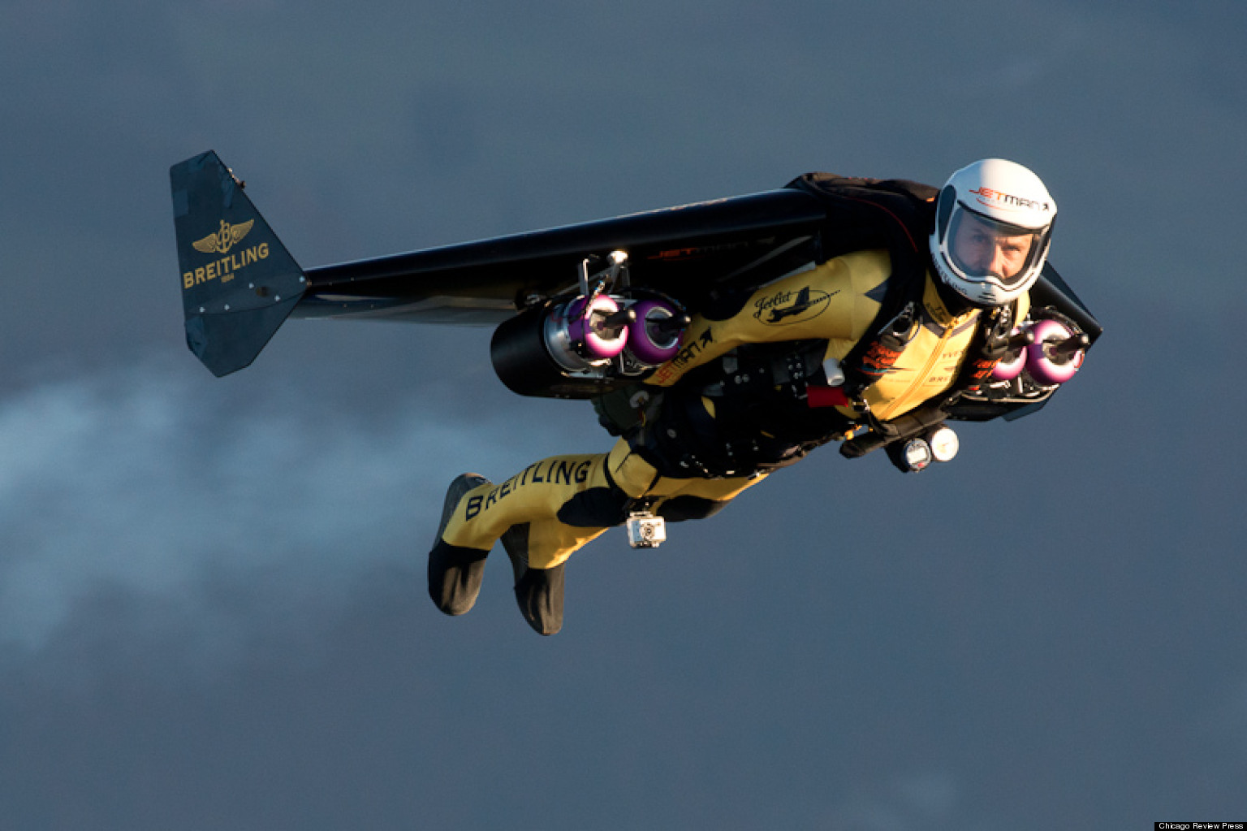
www.huffingtonpost.com

Preparation:
What do you need to prepare for this experience? List steps of preparation in a bulleted format.
- prepare stations with cardboard or newspaper for students to build on
- create powerpoint with history and contemporary forms of transportation; art examples
- build and find examples

Safety:

Be specific about the safety procedures that need to be addressed with students. List all safety issue in a bulleted format.
Be careful with the hot glue.

Action to motivate/Inquiry Questions:
Describe how you will begin the lesson to stimulate student’s interest. How will you pique their curiosity and make them interested and excited about the lesson? What inquiry questions will you pose? Be specific about what you will say and do to motivate students and get them thinking and ready to participate. Be aware of the varying range of learning styles/intelligences of your students. Some ideas might include: telling a story, posing a series of questions, role-playing, etc.
- Ask students how they get around if they are going down the street? Across Fort Collins? Across the US? Across the world?
- What is transportation?
- Is there any kind of transportation that you think is fun?
- What kinds of transportation do you see a lot in Fort Collins?
- How did people 1000 years ago get around? 200 years ago? How do people get around now? How could they get around in the future?

Ideation/Inquiry:
Ideation is the creative process of generating, developing, and communicating new ideas, where an idea is understood as a basic element of thought that can be visual, concrete or abstract. List and describe inquiry questions and processes you will engage students in to help them develop ideas and plans for their artwork.
- Verbally discuss what the students are interested in.
- Show historical and contemporary examples of transportation.
- Sketch to plan

Instruction:
Give a detailed account (in bulleted form) of what you will teach. Be sure to include approximate time for each activity and instructional methodology: skills, lecture, inquiry, etc. Include motivation and ideation/inquiry where appropriate; including what student will understand as a result of the art experience

Day 1 | Instruction - The teacher will... (Be specific about what concepts, information, understandings, etc. will be taught.) Identify instructional methodology. KNOW (Content) and DO (Skill)  - Introduce new project. Begin with a recap of motion: what is motion? What are some things you painted about last week? Then, introduce the word transportation. What is it? What are some examples? What are forms of transportation you see around Fort Collins? How do you get around when you are going down the street? Around Fort Collins? Around the world?  - Begin slide show. Before starting, start brainstorming with students how people got around before there were cars, airplanes and trains. See if they have prior knowledge. Start slide show with historical and contemporary examples of transportation and art works.  - It is your job to create a brand new form of transportation! Start to think about what you will build: Does your object have wings? Wheels? Does it float? How many people does it carry? Are there windows? Is it made to take people really far away? Or close? Is your object made to be used for fun? Or is it going to be very useful and carry many people?  - Students will briefly plan in sketchbooks. Separate a page into two sections and have them draw one thing on each side they want to put on their object (wings, wheels, pedals, etc).  - After working in sketchbooks for a short amount of time, students will be given found objects. Students will be given the opportunity to look through the found object bin to look for materials that they want to use for their transportation, The found object bin will be left out the entire class to allow students multiple chances to look for materials.  - Start clean up. Wrap all student work so they can work on it next week.  - Gather as a class at the end. Talk about what they discovered. What is something new you learned about transportation? What is something new you learned about found oobjects? What is an exciting discovery you would like to add to the discovery board? Is there anything that you wonder about? | Learning - Students will... i.e.: explore ideation by making connections,  comparing, contrasting; synthesize possibilities for each painting technique; etc. (Be specific about what will be the intended result of the instruction as it relates to learning.) UNDERSTAND  - Comparing analogous situations: transferring insights to new contexts  - Making plausible inferences  - Generating solutions  - Developing criteria for evaluation  - Developing intellectal perseverance  - Exercising fair-mindedness  - Practicing Socratic discussion: clarifying and questioning beliefs, theories, or perspectives | Time  - 8:15  - 8:20  - 8:30  - 8:35  - 8:45  - 9:20  - 9:25

Student reflective/inquiry activity:
Sample questions and activities (i.e. games, gallery walk, artist statement, interview) intended to promote deeper thinking, reflection and refined understandings precisely related to the grade level expectations. How will students reflect on their learning? A participatory activity that includes students in finding meaning, inquiring about materials and techniques and reflecting about their experience as it relates to objectives, standards and grade level expectations of the lesson.)
Students will demonstrate how their transportation moves.

Post-Assessment (teacher-centered/objectives as questions):  Have students achieved the objectives and grade level expectations specified in your lesson plan? | Post-Assessment Instrument:  How well have students achieved the objectives and grade level expectations specified in your lesson plan? Include your rubric, checklist, rating scale, etc.
- Using sketches, did the student devise characteristics they will incorporate into their three--dimensional structure?  - Provided a slide show on transportation,did the student identify how technology has influenced the ways humans travel around the world?  - Given found objects, did the student create a transportation object that incorporates realistic characteristics or fictional creations using additive techniques?  - Using completed art work, did the student summarize a story of how their invention will work?  - Using completed sculpture and the hearing the stories behind it, did the student explain how their object is relation to motion? | Student_______________________  1. Devised characteristics to be incorporated into three-dimensional sculpture. ________  2. Identified how technology has influenced the ways humans travel around the world. ________  3. Created a form of transportation that incorporates realistic characteristics or fictional creations using found objects. ________  4. Used completed art work, summarized a story of how their transportation will work. ________  5. Explained how object relates to motion. ________  Super Duper: Work is finished, unique, and has a lot of detail.  Good Work: Work is finished, unique, and has detail.  Okay: Work is finished with little detail.  Almost There! : Work is not finished.

Self-Reflection:
After the lesson is concluded write a brief reflection of what went well, what surprised you, and what you would do differently. Specifically address: (1) To what extent were lesson objectives achieved? (Utilize assessment data to justify your level of achievement.) (2) What changes, omissions, or additions to the lesson would you make if you were to teach again? (3)What do you envision for the next lesson? (Continued practice, reteach content, etc.)
Jenna:
What worked well for this art experience? Why?

So far, I feel like this has been my most successful class. At first I was not sure if the student would understand the concept of transportation and how to create their own, but the material was really exciting for them and in the end they all seemed to understand what the expectations were. The most successful part was that every student was really engaged the entire time, even the students who usually need to leave or sit in time out. I think a lot of this had to do with the material.
What didn’t work well for this art experience? Why?

I think the one thing that I am still doing to wrong is the way I give the group instruction. I say my expectations in more of a question than a firm statement. This gives them the option to say they do not want to participate.
What would you do differently? Why?

I need to continue to work on how I talk to the students. I need to make sure I am being clear and concise in how I give instruction to them so they understand that they do need to participate.

Nicole:
What worked well for this art experience? Why?
The students were all very engaged in the found object activity. They worked through the entire class and were able to create and explain in detail their sculptures. Students were also able to demonstrate how their sculpture evoked the idea of transportation,

What didn’t work well for this art experience? Why?
Clean up could have gone a lot smoother as far as getting students to help with the process. Since students enjoyed the lesson so much more than I expected and they explored the materials so well that the room was covered in feathers and pipe cleaners. Having students help pick up would have made it a much faster process after the class had ended.

What would you do differently? Why?
I would try to find a way to allow students to use the hot glue guns on their own to allow them to easily glue things where they want rather than having to tell me exactly where they want something,

Appendix: Include all handouts, prompts, written materials, rubrics, etc. that will be given to students.

8/9/15 Fahey

