Lesson Plan Title: Moving into colors and painting Length: One Class

Note: Before you plan and write art experiences; pre-assess your students based on the proposed concepts, enduring understandings, and objectives of the unit/lesson(s). You may also gather this information from (previous) teachers, by reviewing already completed art work, consulting curriculum materials, etc., to get a better understanding of what content students already know and what they will need to know to be successful.

Pre-Assessment:
This will need to be done prior to teaching your lesson. Outline the method you will use to determine the skill/knowledge level of your students based on the concepts/enduring understandings/objectives of the lesson. (Hint: turn these into questions.) Be specific in describing what you would recognize as proficient skill/knowledge.
Did students use their sketchbooks and explore their own body movements, and create a painting of a figure or an object in motion.
Given acrylic paint,did students mix colors and apply those colors on their paper
Given examples of Roset and did students identify how movement was captured
Did students use completed art works, to explain their decision making process and a story behind their painting.
By using the discovery board, students were able to communicate and express what they learned to the rest of the class

Performance:
What will students accomplish as a result of this lesson? This can be presented to students in the form of a story. In this narrative the students take on a role and create a learning product about a specific topic for a certain audience. (RAFT – Role / Audience / Format / Topic)
You are a painter who focuses on trying to capture figures in motion. Sometimes you paint people swimming and other times you paint them playing tennis! You have decided that you want to focus on yourself and make a painting that shows what you love to do.

Concepts:
List the big ideas students will be introduced to in the lesson. These ideas are universal, timeless and transferrable. Examples of concepts used in art might include: Composition, Patterns, Technique, Rhythm, Paradox, Influence, Style, Force, Culture, Space/Time/Energy, Line, Law/Rules, Value, Expressions, Emotions, Tradition, Symbol, Movement, Shape, Improvisation, and Observation Look for concepts in the standards, content specific curriculum, etc.
Motion, movement, color

Enduring Understanding (s):
Enduring Understandings show a relationship between two or more concepts; connected with an active verb. The best enduring understandings not only link two or more concepts; but demonstrate why this relationship is important. Like concepts, they are timeless, transferrable and universal. Align Standards, Prepared Graduate Competencies (PGCs) and Grade Level Expectations (GLEs) to Enduring Understandings.
Art can be used to capture a moment in time.

Standards: (All lessons should address all standards.)
1. Observe and Learn to Comprehend
2. Envision and Critique to Reflect
3. Invent and Discover to Create
4. Relate and Connect to Transfer

Objectives/Outcomes/Learning Targets:
Objectives describe a learning experience with a condition → behavior (measurable) → criterion. Aligned to: Bloom’s – Standards – GLEs - Art learning and, when appropriate, Numeracy, Literacy and Technology. Should be written as: Objective. (Bloom’s: _____ - Standard: _____ - GLE: _____ -Art learning: _____ -Numeracy, Literacy, and/or Technology)
- Using gesture drawings and ideas from last class, TSWBAT create a painting of a figure that accurately depicts motion. (Bloom’s:Creating - Standard: # 3 - GLE: # 3.1 -Art learning: Create -Numeracy, Literacy, and Technology)
- Given acrylic paint, TSWBAT mix colors and thoughtfully apply those colors on their paper. (Bloom’s: Applying - Standard: # 3 - GLE: # 3.1-Art learning: Explore -Numeracy)
- Given examples of Roset and Meyerson, TSWBAT accurately identify how movement was captured. (Bloom’s: Analyzing - Standard: # 2- GLE: # 2.1 - Art learning: Identify - Numeracy, Literacy, and Technology)
- By using the discovery board, TSWBAT communicate how they portrayed movement in their paintings. (Bloom’s: Remember - Standard: # 2 - GLE: # 2.1 -Art learning: Communicate - Numeracy, Literacy)
- Using their completed artworks, TSWBAT explain their decision making process by sharing the story behind their painting. (Bloom’s:Understanding - Standard: # 4 - GLE: # 4.1 -Art learning: Intent -Numeracy, Literacy)

Differentiation:
Explain specifically how you have addressed the needs of exceptional students at both end of the skill and cognitive scale. Describe the strategies you will use for students who are already proficient and need growth beyond what you have planned for the rest of the class, as well as modifications for students with physical and/or cognitive challenges. Students must still meet the objectives.

Differentiation:  (Multiple means for students to access content and multiple modes for student to express understanding.) | Access (Resources and/or Process) | Expression (Products and/or Performance)
 | - Drawing, planning verbally, exploring motion kinesthetically, and working three dimensionally  - Work and share ideas in small groups | - Planning process happens in a wide variety of ways
Extensions for depth and complexity: | Access (Resources and/or Process) | Expression (Products and/or Performance)
 | 1.Students can create a story based on their painting and verbally communicate at the end of class.  2.Students can create and write a title for the art work. | - Students can reflect on their ideas and artistic decisions to create a story, therefore engaging in literacy practice and improvise creative ideas.  - Students can practice writing skills and internalize their decisions to create the title.

Literacy:
List terms (vocabulary) specific to the topic that students will be introduced to in the lesson and describe how literacy is integrated into the lesson.
Vocabulary: two-dimensional, discovery, movement.

Literacy Integration: Verbalization of process.

Materials:
Must be grade level appropriate. List everything you will need for this lesson, including art supplies and tools. (These are the materials students will use.) List all materials in a bulleted format.
Paint brushes, acrylic paint, white and black paper, cups, pipe cleaners, scissors.

Resources:

List all visual aids and reference material (books, slides, posters, etc. Be specific; include title, artist, etc. Make reference to where the material can be found. (These are the resources used by the teacher to support/develop the lesson.) List all resources in a bulleted format.
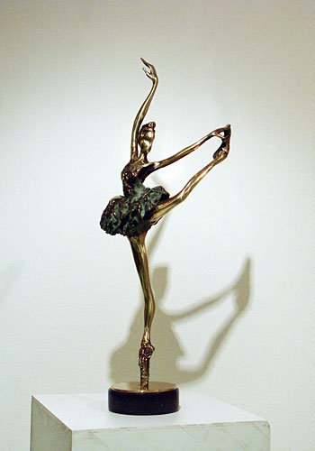
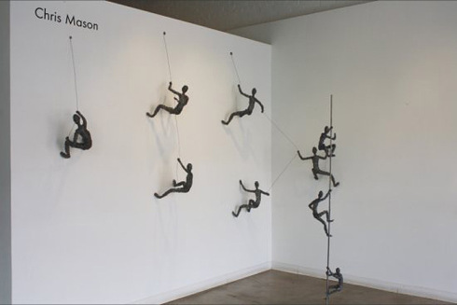 Ivan Minekov
Social Climbing, Chris Mason https://fineartebooks.wordpress.com/tag/modern-sculpture/
http://collabcubed.com/2012/05/08/chris-mason-social-climbing/
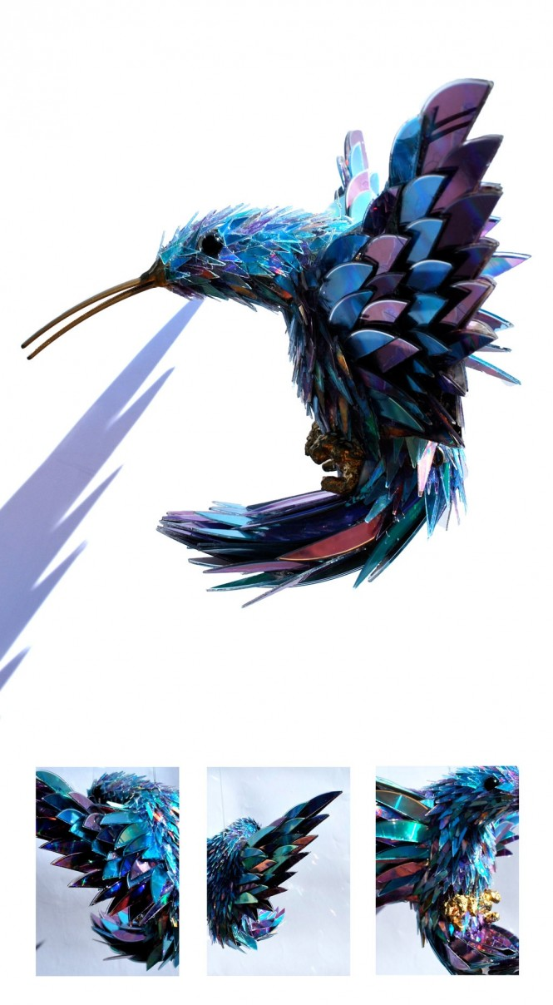
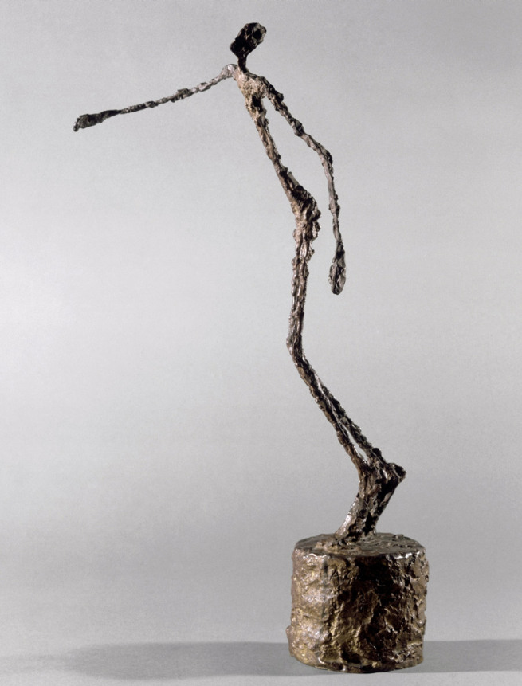
Sean E. Avery,http://www.home-designing.com/2012/02/stunning-sculptures-made-from-discarded-cd-fragments Alberto Giacometti
Homme qui chavire/Falling Man
1950
Bronze, 60 x 22 x 36 cm
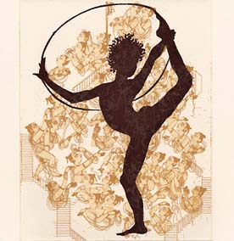
http://artblart.com/tag/alberto-giacometti-figurine-dans-une-boite-entre-deux-boites-qui-sont-des-maisons/
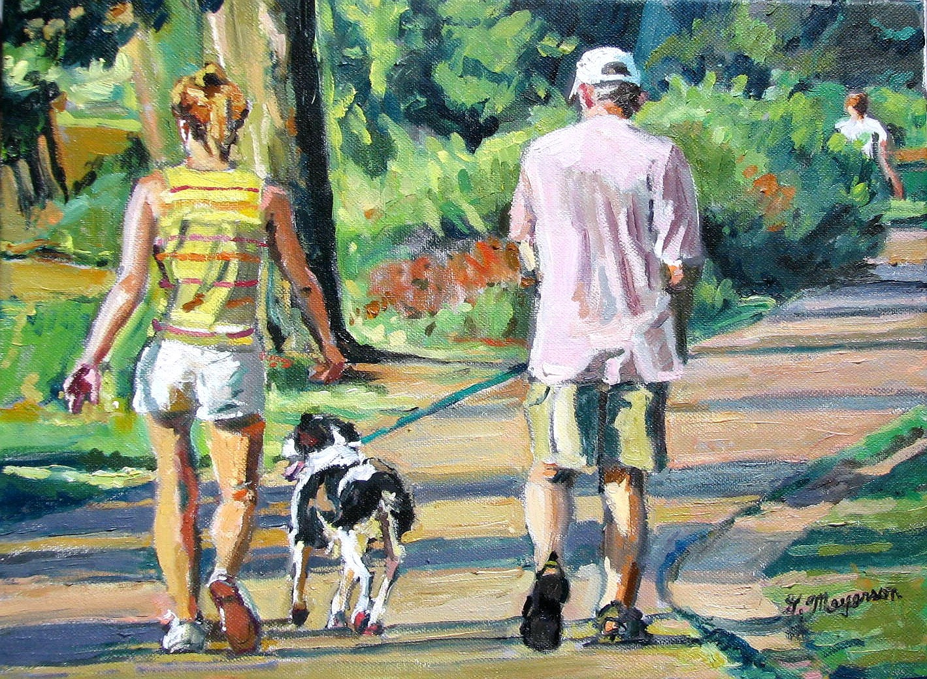
Gwen Meyerson
https://www.etsy.com/listing/69845224/summer-fine-art-print-8x10-man-and-woman
Shahzia Sikander
Traffic Jam http://www.artnet.com/Magazine/news/manson/manson4-4-5.asp

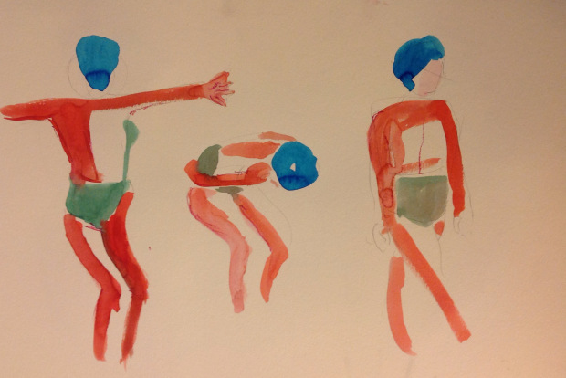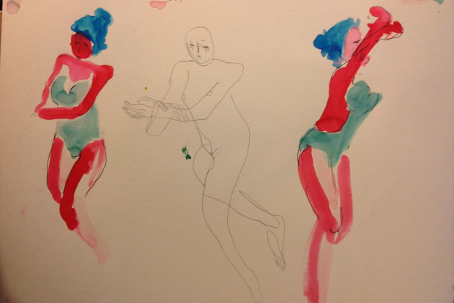
Conrad Roset
https://unbocetoaldia.wordpress.com/2014/10/24/workshop-conrad-roset-iii-2/

Preparation:
What do you need to prepare for this experience? List steps of preparation in a bulleted format.
- create slide show
- create painting examples

Safety:

Be specific about the safety procedures that need to be addressed with students. List all safety issue in a bulleted format.
- be careful with the acrylic paint, it goes only on the brush.
- if working with pipe cleaners, do not hit other students with them.

Action to motivate/Inquiry Questions:
Describe how you will begin the lesson to stimulate student’s interest. How will you pique their curiosity and make them interested and excited about the lesson? What inquiry questions will you pose? Be specific about what you will say and do to motivate students and get them thinking and ready to participate. Be aware of the varying range of learning styles/intelligences of your students. Some ideas might include: telling a story, posing a series of questions, role-playing, etc.
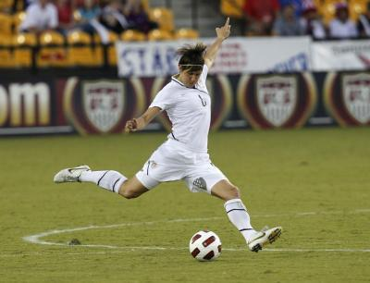
“If you were playing soccer what would it look when you kicked the ball?”
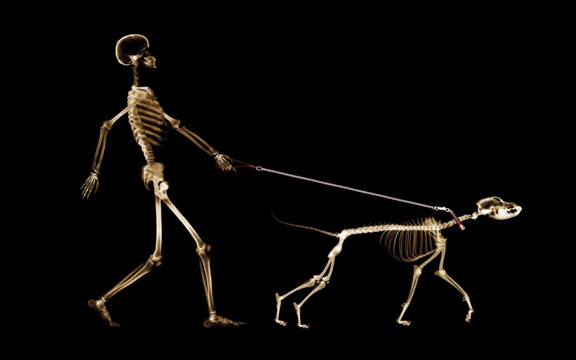
http://www.livestrong.com/article/245450-techniques-to-kick-a-soccer-ball-far/
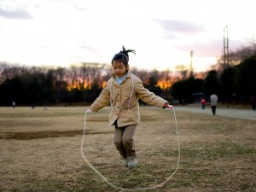
http://transformfxfitness.com/2014/02/10-reasons-you-should-be-jumping-rope/

http://www.aliexpress.com/item/HOT-PRINT-OIL-PAINTING-40-50-THE-SKULL-ART-WALKING-THE-DOG-Canvas-Print-WALL-ART/32341488566.html

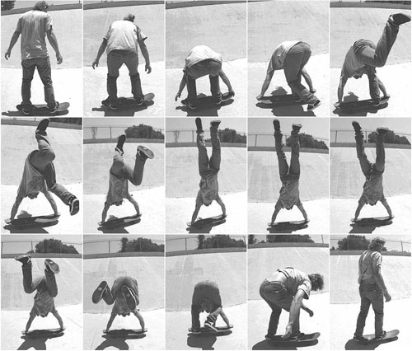

http://www.theworldsbestever.com/2011/03/09/say-what-2/

Ideation/Inquiry:
Ideation is the creative process of generating, developing, and communicating new ideas, where an idea is understood as a basic element of thought that can be visual, concrete or abstract. List and describe inquiry questions and processes you will engage students in to help them develop ideas and plans for their artwork.
- “Freeze” game to help students see and feel what movement looks like (from last class)
- Gesture painting activity (from last class)
- Color mixing demo

Instruction:
Give a detailed account (in bulleted form) of what you will teach. Be sure to include approximate time for each activity and instructional methodology: skills, lecture, inquiry, etc. Include motivation and ideation/inquiry where appropriate; including what student will understand as a result of the art experience

Day 1 | Instruction - The teacher will... (Be specific about what concepts, information, understandings, etc. will be taught.) Identify instructional methodology. KNOW (Content) and DO (Skill)  - Start off class at the purple rug.Talk about the discovery board. What are some things you learned about motion? Did you learn anything about working with pipe cleaners? Were there any questions from last week?  - Introduce the next lesson Just like last week, we are going to make art about motion. We are going to be working with acrylic paint and two different types of paper. We are also going to explore mixing colors. Think about some questions we asked last week:  - What do things look like in art that show movement? How can things that are not moving look like they are?  - Explain some of your sculptures, what did you do to show motion?  - What do you know about mixing colors?  - After talking about some of the concepts from last week, we will show a more examples of paintings that show movement. Ask the students questions to see what makes the figures look like they are moving.  - Have students gather around the teacher. The teacher will do a quick demonstration on color theory. She will show only one color mixture (yellow and blue makes green), then she will explain that the students will be exploring what other colors mix together to make more colors. We will put those findings on the discovery board.  - Explain specific expectations for the project:  - We will be painting a FIGURE in the painting, if students want to draw other things (dogs, toys, buildings), it must have something to do with the figure.  - We will be making a minimum of two paintings, one must be one white paper, one must be on black paper.  - When students are mixing colors, they must only be mixing two colors at a time.  - Students can begin to work on their paintings. The figure in motion can be doing whatever the students want it to be doing. Teachers will be helping students with colors and ideas for paintings while documenting.  - If students finish early and do not want to paint anymore, they will have the option to build with the pipe cleaners again. If they do not want to do either of those, they can color with crayons in their sketchbook.  - Start clean up. We will pick two helpers to collect the paint brushes, two students to collect water cups, and the rest of the students will organize their tables.  - Once students have cleaned, we will sit in the front of the classroom and fill our the discovery board. What did you learn about motion? What did you learn about mixing colors? | Learning - Students will... i.e.: explore ideation by making connections,  comparing, contrasting; synthesize possibilities for each painting technique; etc. (Be specific about what will be the intended result of the instruction as it relates to learning.) UNDERSTAND  - Comparing analogous situations: transferring insights to new contexts  - Clarifying and analyzing the meanings of words or phrases  - Analyzing or evaluating action  - Refining generalizations and avoiding oversimplification; making plausible inferences, predictions, or interpretations  - comparing and contrasting ideals with actual practice  - Exercising fair-mindedness and developing intellectual good faith or integrity  - exercising fair-mindedness  - Reasoning dialogically: comparing perspectives, interpretations; practicing Socratic discussion: clarifying and questioning | Time  - 8:20  - 8:30  - 8:35  - 8:40  - 8:45  - 8:50  - 9:10  - 9:20  - 9:30

Student reflective/inquiry activity:
Sample questions and activities (i.e. games, gallery walk, artist statement, interview) intended to promote deeper thinking, reflection and refined understandings precisely related to the grade level expectations. How will students reflect on their learning? A participatory activity that includes students in finding meaning, inquiring about materials and techniques and reflecting about their experience as it relates to objectives, standards and grade level expectations of the lesson.)
Discovery board discussion about what the students learned in class.

Post-Assessment (teacher-centered/objectives as questions):  Have students achieved the objectives and grade level expectations specified in your lesson plan? | Post-Assessment Instrument:  How well have students achieved the objectives and grade level expectations specified in your lesson plan? Include your rubric, checklist, rating scale, etc.
- Did students use gesture drawings to create a painting of a figure and objects in motion?  - Did students use acrylic paint to mix colors and apply those colors in their paper?  - Given examples of Roset and Meyerson, did students identify how movement was captured?  - When using the discovery board, did communicate and express how they portrayed movement in their paintings?  - Using their completed artworks, did the students explain their decision making process and story behind their painting? | Student_______________________  1. Used gesture drawings to create a painting of a figure and objects in motion. ________  2. Used acrylic paint to mix colors and apply those colors on their painting. ________  3. Identified how movement was captured in examples of Roset and Meyerson. ________  4. Communicated and expressed how movement was portrayed in painting. ________  5. Explained decision making process and story behind painting. ________  Super Duper: Work is finished, unique, and has a lot of detail.  Good Work: Work is finished, unique, and has detail.  Okay: Work is finished with little detail.  Almost There! : Work is not finished.

Self-Reflection:
After the lesson is concluded write a brief reflection of what went well, what surprised you, and what you would do differently. Specifically address: (1) To what extent were lesson objectives achieved? (Utilize assessment data to justify your level of achievement.) (2) What changes, omissions, or additions to the lesson would you make if you were to teach again? (3)What do you envision for the next lesson? (Continued practice, reteach content, etc.)
Nicole:
What worked well for this art experience? Why?
We were able to get to do our lesson in the gym which allowed the students to spread out and paint on larger pieces of paper. The students were able to capture the idea of movements in many of their paintings!

What didn’t work well for this art experience? Why?
Walking to the gym with the students could have gone a lot smoother than it did. I should have set clear expectations about how we act in the hall to make the transition from room to room much easier. Clean up in the gym was also a little difficult since there were not clear seats and students had started to get up and run around.

What would you do differently? Why?
I would have a back up activity for students to do when they were finished so that kids are not up and running around the room. While the students were very engaged in the activity it did not take as long as I had planned which made it hard to keep everyone quiet and on task.

Jenna
What worked well for this art experience? Why?

For everything that could have potentially gone wrong, this lesson went really smooth. Since the high school kids were gone, we got to use the gym to create big paintings. Timing was a little difficult since breakfast was set up before school, so I went to set up while Nicole introduced the new project. This time, we planned ahead for if we worked in the class or the gym, so it was great being prepared. Right when the students walked in, one of the more rowdy boys got excited and tripped over the butcher paper laid out and spilled some water, so I was instantly worried things were going to get too messy. However, the students all sat down at a station and quietly waited for their paint. There was a lot of great mixing of colors and exploring ideas of movement. It was obvious the students were putting a lot of thought into their paintings. Once they were done painting on the big paper, students painted on colored paper. They worked really consistently the entire class.

What didn’t work well for this art experience? Why?

When some of the students got finished and a little antsy, Nicole and I did not really know what to do with the students. Some were spinning on the floor, others started to walk around while others painted. We did not really know how to balance the students who were still working and the students that were done. Luckily, our para Pete was there and took initiative. He played a game with the ones who were finished so they could get rid of some energy and run around the gym.

What would you do differently? Why?

After seeing this, I think next time this happens we really need to utilize the co-teaching structure. While today we took on roles of teacher and documenter, this would have been a great opportunity to let one teacher work with the students painting and one do something more active that is relevant to the lesson (which motion is perfect for that). Next time, I hope to communicate more and really take initiative when I see that some kids are ready to move on so that everyone is getting the attention they need.

Appendix: Include all handouts, prompts, written materials, rubrics, etc. that will be given to students.

8/9/15 Fahey

