Lesson Plan Title: Halloween Centers Length:One class

Note: Before you plan and write art experiences; pre-assess your students based on the proposed concepts, enduring understandings, and objectives of the unit/lesson(s). You may also gather this information from (previous) teachers, by reviewing already completed art work, consulting curriculum materials, etc., to get a better understanding of what content students already know and what they will need to know to be successful.

Pre-Assessment:
This will need to be done prior to teaching your lesson. Outline the method you will use to determine the skill/knowledge level of your students based on the concepts/enduring understandings/objectives of the lesson. (Hint: turn these into questions.) Be specific in describing what you would recognize as proficient skill/knowledge.
Can students…
- Build clay using slip and score techniques
- Mix colors with acrylic paint
- Draw with oil pastels
- Build sculptures from found objects?

Performance:
What will students accomplish as a result of this lesson? This can be presented to students in the form of a story. In this narrative the students take on a role and create a learning product about a specific topic for a certain audience. (RAFT – Role / Audience / Format / Topic)
You are the Townspeople of Fort Collinsvania and you are visiting the lab of Madam Cluckers. You are here to see what exactly she has been up to in that creepy castle of hers! When you arrive she introduces herself and tells you that she needs your help with an experiment!
“Welcome to my lab! This is in fact the same lab that Frankenstein was created, as well as many other creatures and things! It is great to have so many townspeople with us today! We are going to experiment with all the different kinds of art you have already learned, plus more! Today we are going to be working with different creepy ideas! We will be trying to make a haunted house, masks, monnnsssttterrrsss, and stories.

Concepts:
List the big ideas students will be introduced to in the lesson. These ideas are universal, timeless and transferrable. Examples of concepts used in art might include: Composition, Patterns, Technique, Rhythm, Paradox, Influence, Style, Force, Culture, Space/Time/Energy, Line, Law/Rules, Value, Expressions, Emotions, Tradition, Symbol, Movement, Shape, Improvisation, and Observation Look for concepts in the standards, content specific curriculum, etc.
Choice, centers, experimentation, two-dimensional, three-dimensional.

Enduring Understanding (s):
Enduring Understandings show a relationship between two or more concepts; connected with an active verb. The best enduring understandings not only link two or more concepts; but demonstrate why this relationship is important. Like concepts, they are timeless, transferrable and universal. Align Standards, Prepared Graduate Competencies (PGCs) and Grade Level Expectations (GLEs) to Enduring Understandings.
- Artists can create art work in multiple mediums after experimenting with various processes.

Standards: (All lessons should address all standards.)
1. Observe and Learn to Comprehend
2. Envision and Critique to Reflect
3. Invent and Discover to Create
4. Relate and Connect to Transfer

Objectives/Outcomes/Learning Targets:
Objectives describe a learning experience with a condition → behavior (measurable) → criterion. Aligned to: Bloom’s – Standards – GLEs - Art learning and, when appropriate, Numeracy, Literacy and Technology. Should be written as: Objective. (Bloom’s: _____ - Standard: _____ - GLE: _____ -Art learning: _____ -Numeracy, Literacy, and/or Technology)
- Provided various art mediums, SWBAT explore art materials to create an artwork that they can tell a story about. (Bloom’s: Analyzing - Standard: # 3 - GLE: # 3.1 - Art learning: Create - Numeracy, Literacy)
- Given images, SWBAT look at contemporary images and tell a story about the image. (Bloom’s: Remembering - Standard: # 2 - GLE: # 2.1 - Art learning: Observe - Numeracy, Literacy)
- After finishing art work, SWBAT tell a story about their art work during a class discussion. (Bloom’s: Remembering - Standard: # 4 - GLE: # 4.1 - Art learning: Reflect - Literacy)

Differentiation:
Explain specifically how you have addressed the needs of exceptional students at both end of the skill and cognitive scale. Describe the strategies you will use for students who are already proficient and need growth beyond what you have planned for the rest of the class, as well as modifications for students with physical and/or cognitive challenges. Students must still meet the objectives.

Differentiation:  (Multiple means for students to access content and multiple modes for student to express understanding.) | Access (Resources and/or Process) | Expression (Products and/or Performance)
 | Centers with different mediums and themes. | Choice of the medium and subject matter.
Extensions for depth and complexity: | Access (Resources and/or Process) | Expression (Products and/or Performance)
 | - Story telling.  2. Environments. | - Students can create multiple scenes and create a short story book.  - Students can create spaces for their Halloween creatures to live in.

Literacy:
List terms (vocabulary) specific to the topic that students will be introduced to in the lesson and describe how literacy is integrated into the lesson.
Vocabulary: Two-dimensional, three-dimensional, centers, choice, scenes.

Literacy: story telling

Materials:
Must be grade level appropriate. List everything you will need for this lesson, including art supplies and tools. (These are the materials students will use.) List all materials in a bulleted format.
Acrylic Paint
Brushes
Paper
Oil pastels
Found-objects
Hot glue
Plexi glass
water tub
Blotter paper
Modeling clay
Trash bag place mats

Resources:

List all visual aids and reference material (books, slides, posters, etc. Be specific; include title, artist, etc. Make reference to where the material can be found. (These are the resources used by the teacher to support/develop the lesson.) List all resources in a bulleted format.
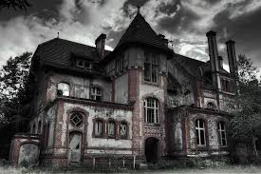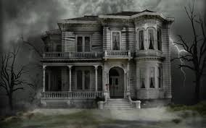
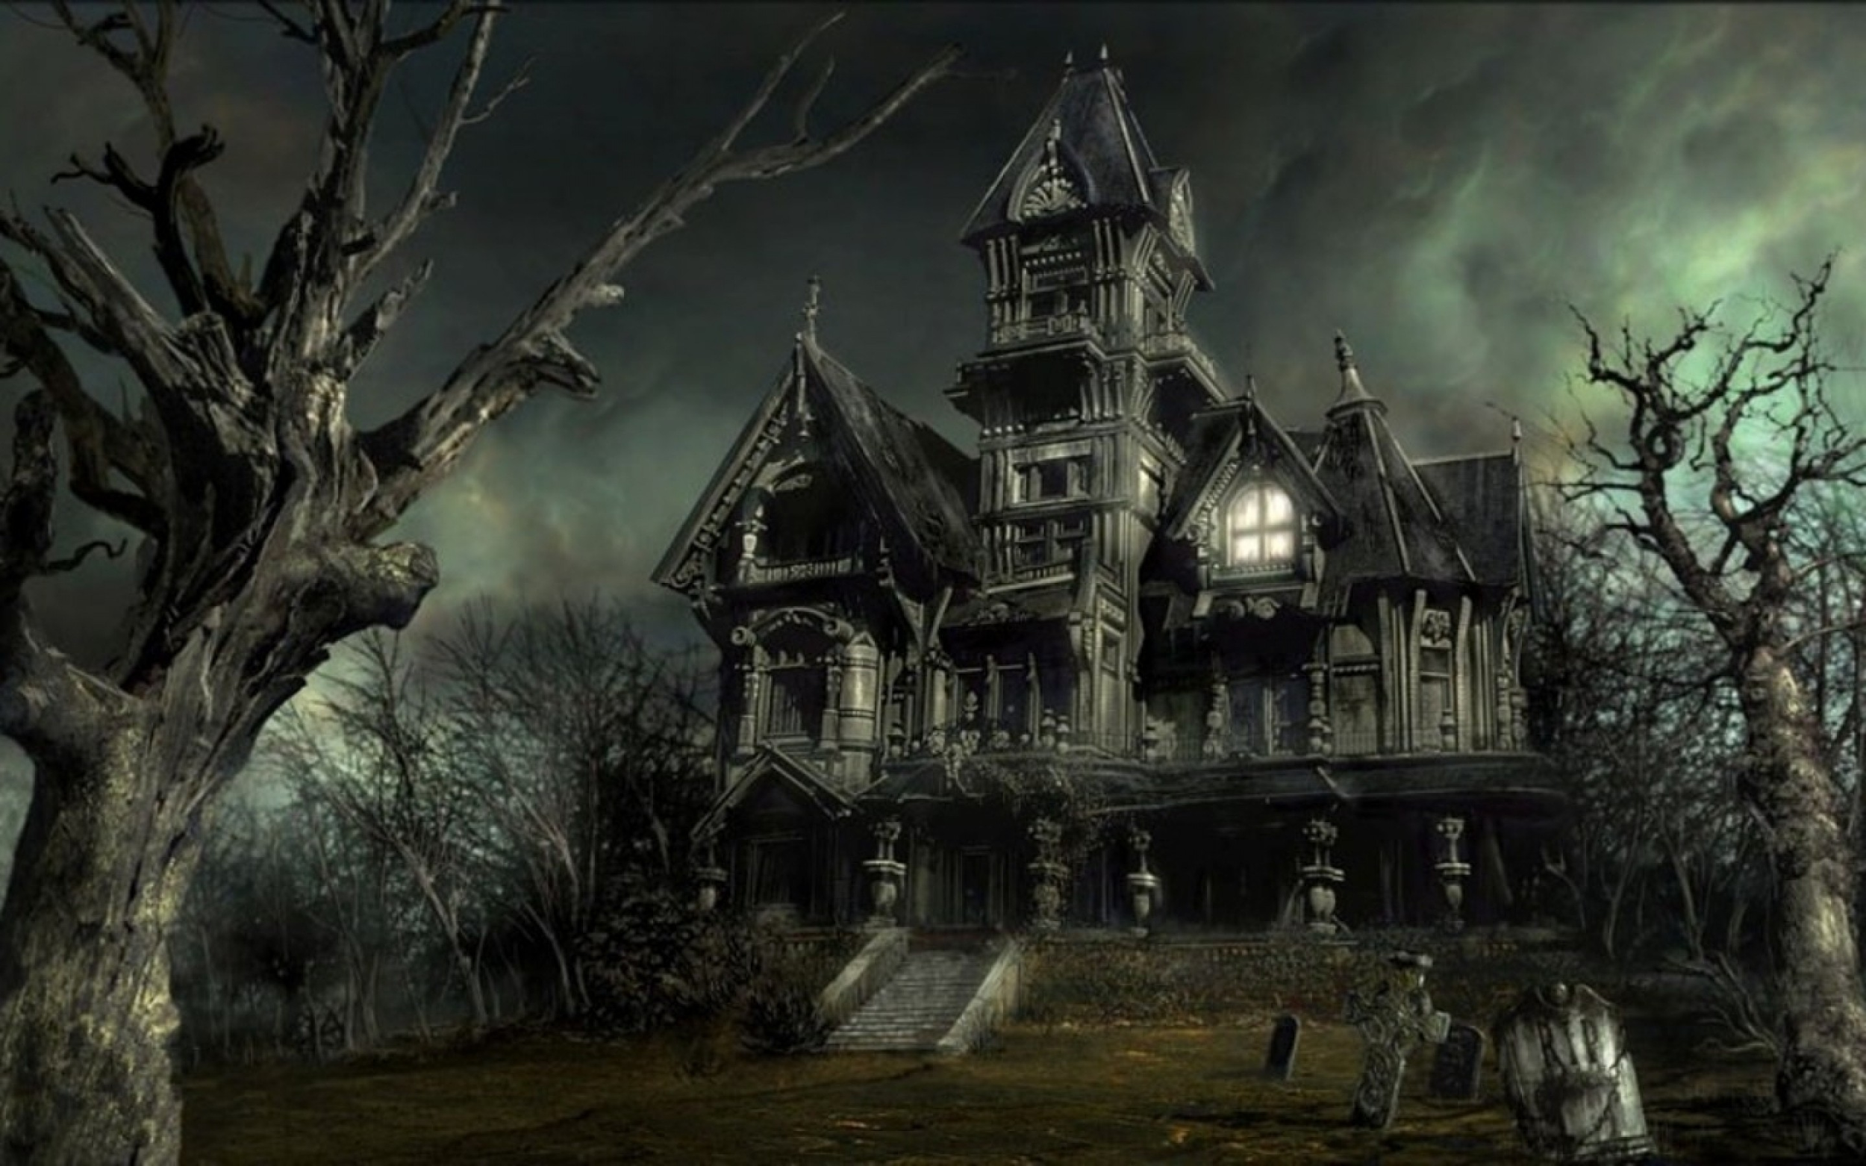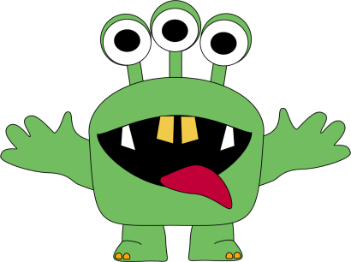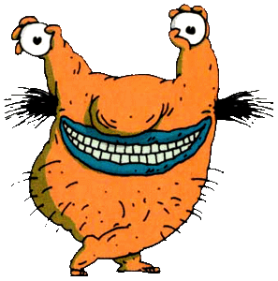

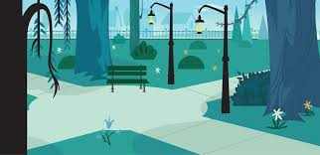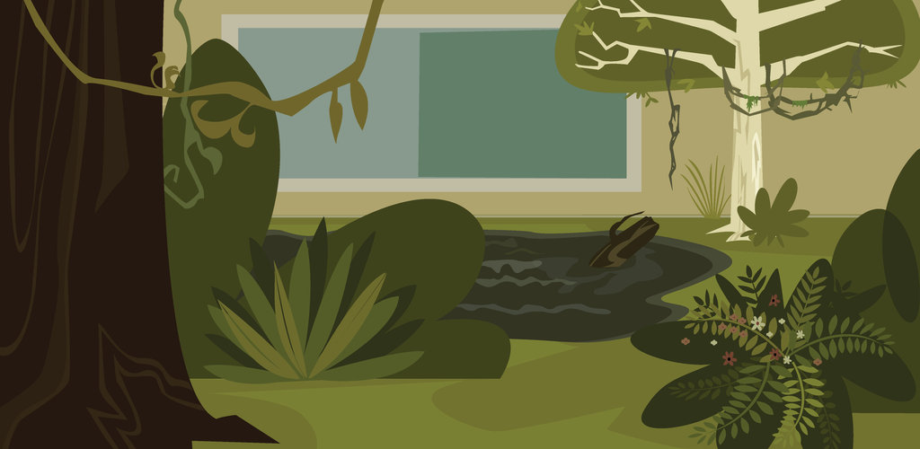

Preparation:
What do you need to prepare for this experience? List steps of preparation in a bulleted format.
Prepare examples of monoprints
prep slide show
Prep small found-object bin
Cut smaller paper for story scenes
Create poster for rules

Safety:

Be specific about the safety procedures that need to be addressed with students. List all safety issue in a bulleted format.
Be careful with hot glue gun. Be sure to wear the safety gloves.

Action to motivate/Inquiry Questions:
Describe how you will begin the lesson to stimulate student’s interest. How will you pique their curiosity and make them interested and excited about the lesson? What inquiry questions will you pose? Be specific about what you will say and do to motivate students and get them thinking and ready to participate. Be aware of the varying range of learning styles/intelligences of your students. Some ideas might include: telling a story, posing a series of questions, role-playing, etc.
Welcome to my lab! I see you are all interested in the scary, the interesting, and the unknown…

Today, us scientists are going to wander around the lab and experiment with anything we find! We hope you try one of everything, but you can create art with just one medium, or all mediums! The choice is yours...

Ideation/Inquiry:
Ideation is the creative process of generating, developing, and communicating new ideas, where an idea is understood as a basic element of thought that can be visual, concrete or abstract. List and describe inquiry questions and processes you will engage students in to help them develop ideas and plans for their artwork.
Choice-based centers will allow students to engage with mediums that are relevant to them.

Instruction:
Give a detailed account (in bulleted form) of what you will teach. Be sure to include approximate time for each activity and instructional methodology: skills, lecture, inquiry, etc. Include motivation and ideation/inquiry where appropriate; including what student will understand as a result of the art experience

Day 1 | Instruction - The teacher will... (Be specific about what concepts, information, understandings, etc. will be taught.) Identify instructional methodology. KNOW (Content) and DO (Skill)  - Students will arrive and sit on the purple rug. Teachers, dressed as mad scientist and Frankenstein will enter the room. Scientist will start to tell the story of how they found different body parts and a brain. Tell story of how the whole town chased with pitchforks and torches. After all that, the final art work was…..FRANKENSTEIN! Since it is Halloween, we are going to allow the students to choose what kind of art they do ( which we will later explain). While we are creating work, think about the story behind it.  - Start slide show that explains different ideas that the students can focus on:  - Create a scene of a story  - Create a creepy creature  - Create a haunted house  - Create a mask  - Take students around the laboratory to each station:  - Painting (acrylic paint)  - Drawing (Crayons, markers, oil pastels)  - Found-Object Sculptures  - Mono-prints  - Modeling clay  - Ideation station ( images, sketchbooks, etc.)  What have you done before? What do you remember?  Go over the rules of the centers.  - Only 4 students at each station  4. Mono-print demonstration: have example half made, finish it and print it.  5. Let students begin at whatever station they want to go to. They have the option to create what they want, and use whatever mediums they want to. The goal of the lesson is to get them to create with mediums that interest them. Have students think about the story of their piece. If it is a scene, what is the story that built up to that moment in time. If it is a mask, what is it of? Where does it live? What does it do every day? If it is a house, who lives in the house? What makes it haunted? What are special features of the house? If it is a creature, what does it look like? What does it eat? Where does it live? What does it do every day?  6. Clean up: Put all materials into the the bins on the tables. Leave out scissors.  7. Class discussion about what they created in the lab today. What are some stories? Have students share some of their ideas. What did you learn? | Learning - Students will... i.e.: explore ideation by making connections,  comparing, contrasting; synthesize possibilities for each painting technique; etc. (Be specific about what will be the intended result of the instruction as it relates to learning.) UNDERSTAND  - Thinking independently  - Listening critically  - reasoning dialogically  - Listening critically  - Generating solutions  - Exercising fair-mindedness  - Practicing Socratic discussion | Time  - 8:15  - 8:20  - 8:30  - 8:45  - 8:50  - 9:15  - 9:25

Student reflective/inquiry activity:
Sample questions and activities (i.e. games, gallery walk, artist statement, interview) intended to promote deeper thinking, reflection and refined understandings precisely related to the grade level expectations. How will students reflect on their learning? A participatory activity that includes students in finding meaning, inquiring about materials and techniques and reflecting about their experience as it relates to objectives, standards and grade level expectations of the lesson.)
Class discussions. What did you make? Why? How do people know what it is? What is the story behind it?

Post-Assessment (teacher-centered/objectives as questions):  Have students achieved the objectives and grade level expectations specified in your lesson plan? | Post-Assessment Instrument:  How well have students achieved the objectives and grade level expectations specified in your lesson plan? Include your rubric, checklist, rating scale, etc.
- Provided various art mediums, did students explore art materials in centers.  - Given the power point, did students communicate verbally features of a monster, haunted house, and masks.  - Provided images of themes, did students create art work that incorporates story telling, creatures, masks, or haunted houses.  - Given a variety of materials, did students create art work that tells a story.  - After finishing art work, did students tell a story about their art work during a class discussion. | Student_______________________  1. Able to explore and use multiple materials. _____________  2. Able to communicate features of a haunted house, monster, and masks. ____________  3. Able to incorporate storytelling, creatures, masks, and haunted houses. _____________  4. Able to use materials to create a piece of art that tells a story. ______________  5. Able to tell a story about their piece in a class discussion. ______________  Super Duper: Work is finished, unique, and has a lot of detail.  Good Work: Work is finished, unique, and has detail.  Okay: Work is finished with little detail.  Almost There! : Work is not finished.

Self-Reflection:
After the lesson is concluded write a brief reflection of what went well, what surprised you, and what you would do differently. Specifically address: (1) To what extent were lesson objectives achieved? (Utilize assessment data to justify your level of achievement.) (2) What changes, omissions, or additions to the lesson would you make if you were to teach again? (3)What do you envision for the next lesson? (Continued practice, reteach content, etc.)
Nicole:
What worked well for this art experience? Why?
Giving the students the opportunity to work through centers seemed to work well this week. They all were engaged the entire class period and it was a great way to give them the opportunity to work and to move around. Giving them time to get up and move from the different centers helped with keeping the kids focused. It helped them to burn off some energy and not get antsy just sitting at one spot for the entire period.

What didn’t work well for this art experience? Why?
I think that if we had only done two or three centers this would have worked much better. There were five centers so the students only got seven minutes at each center. This wasn’t a huge issue at most centers, but we had a found object center and it seemed hard for students to finish their found object pieces in just seven minutes.

What would you do differently? Why?
I definitely would only have two or three centers if I did this again, five seemed like too many. I feel like the students need a little more time to actually have time to create.

Jenna:
What worked well for this art experience? Why?
This week we did centers, which overall ran pretty smoothly. We explained the rules of the centers before we started and had a printmaking demo, then we were ready to start. There were only a few minor issues (like water spilling and slay on the floor) but other than that, I was very happy with how the students did and how engaged they were.

Also, Nicole and I split up on the different sides of the class. She was really helpful with the mono print center which was perfect as it gave me time to document and help at other places.

What didn’t work well for this art experience? Why?
We had five different stations set up, so the students only had about 7 minutes with each medium. They did not seem to mind, but I think it was not truly enough time for them to explore certain centers like the found-object sculptures. Also, we did not really plan what to do with the finished paintings and prints, so we placed them on the floor. This wasn’t a huge deal, but one student ended up stepping on the wet paint.

What would you do differently? Why?
Next time we do centers, I would think it would work better if we had less stations. If the goal of the lesson is to get students to explore materials, they really need a good amount of time to do that.

Appendix: Include all handouts, prompts, written materials, rubrics, etc. that will be given to students.

8/9/15 Fahey

